CSAI 301 - Project Phase 1
Vacuum Cleaner Robot Problem
Ahmed Wael 202201415
Problem Description
The Vacuum Cleaner Robot Problem involves a robot operating in a 5x5 grid environment where certain cells are dirty and need to be cleaned. The robot must navigate the grid and clean all dirty cells while minimizing the total cost of operations.
With a floor size of 5*5 (25 cells total) - 10 cells dirty and the robot can take actions like Move Up, Down, Left, Right, and Clean and each action has a cost of 1

Algorithms Implemented
Breadth-First Search (BFS)
- Strategy: Explores level by level (FIFO queue)
- Complete: Yes
- Optimal: Yes (for uniform cost)
- Time Complexity: O(b^d)
- Space Complexity: O(b^d)
Depth-First Search (DFS)
- Strategy: Explores deep paths first (LIFO stack)
- Complete: Yes (with depth limit)
- Optimal: Yes
- Time Complexity: O(b^m)
- Space Complexity: O(bm)
Uniform Cost Search (UCS)
- Strategy: Expands lowest cost node first
- Complete: Yes
- Optimal: Yes
- Time Complexity: O(b^(C*/ε))
- Space Complexity: O(b^(C*/ε))
Iterative Deepening Search (IDS)
- Strategy: Combines BFS and DFS benefits
- Complete: Yes
- Optimal: Yes (for uniform cost)
- Time Complexity: O(b^d)
- Space Complexity: O(bd)
Greedy Best-First Search
- Strategy: Expands node with lowest h(n)
- Complete: Yes
- Optimal: Yes
- Fast but potentially suboptimal
A* Search
- Strategy: Expands node with lowest f(n) = g(n) + h(n)
- Complete: Yes
- Optimal: Yes (with admissible heuristic)
- Time Complexity: O(b^d)
- Space Complexity: O(b^d)
Performance Results
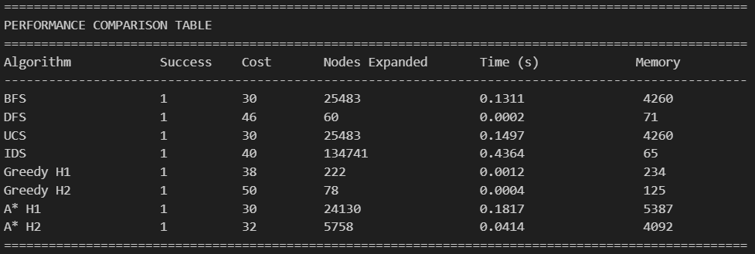
Performance Table:

Performance Charts:
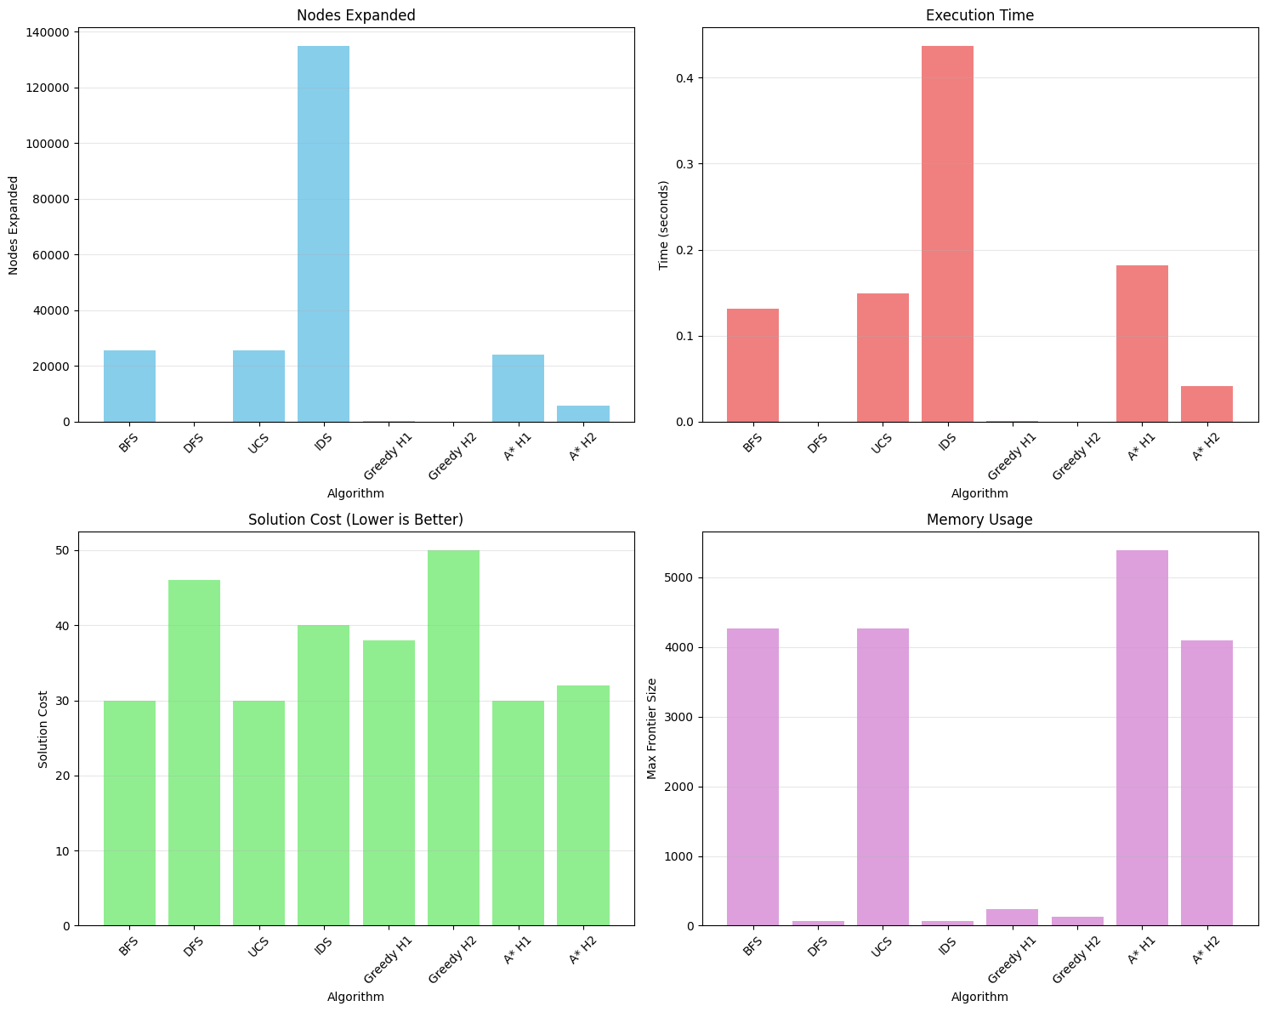
Solution Path for every algorithm
